Week 02 – HTTP, HTTPS, DNS
What I focused on
This week I wanted to understand what actually happens when I open a website: how HTTP/HTTPS works and where DNS fits in.

What I did
- Opened Chrome/Firefox Developer Tools → Network tab and loaded a few websites.
- Clicked on one main request and checked:
  - Request URL
  - Method (GET)
  - Status code (200, 404, etc.)
  - Important headers like Host and User-Agent
- Tried the same site with http:// and https:// (where possible) to see the difference in the browser (padlock, port 80 vs 443).
- Used nslookup google.com in the terminal to see which IP address the domain resolves to and which DNS server answered.
- Made a small ports cheat sheet:
Port | Protocol | Use
80 | HTTP | Web (no TLS)
443 | HTTPS | Web (with TLS)
22 | SSH | Remote shell
25 | SMTP | Mail server
53 | DNS | Name lookup

Key concepts (in my own words)
- HTTP request/response:
When I open a page, the browser sends an HTTP request (for example, GET /) and the server replies with a status code (200, 404, etc.), headers, and the page content.
- HTTP vs HTTPS:
HTTP uses port 80 and is not encrypted. HTTPS uses port 443 and wraps HTTP inside TLS, so the traffic is encrypted and harder to read or modify on the network.
- Role of DNS:
DNS is the “phonebook” of the internet. When I type google.com, my system uses DNS (for example via nslookup google.com) to find the IP address of that name. Only after it knows the IP can the browser open a connection and send the HTTP/HTTPS request.

Commands I used
- nslookup google.com – to resolve the domain name to an IP address and see which DNS server my system is using.

Below is the result:
1.nslookup google.com / nslookup yahoo.com
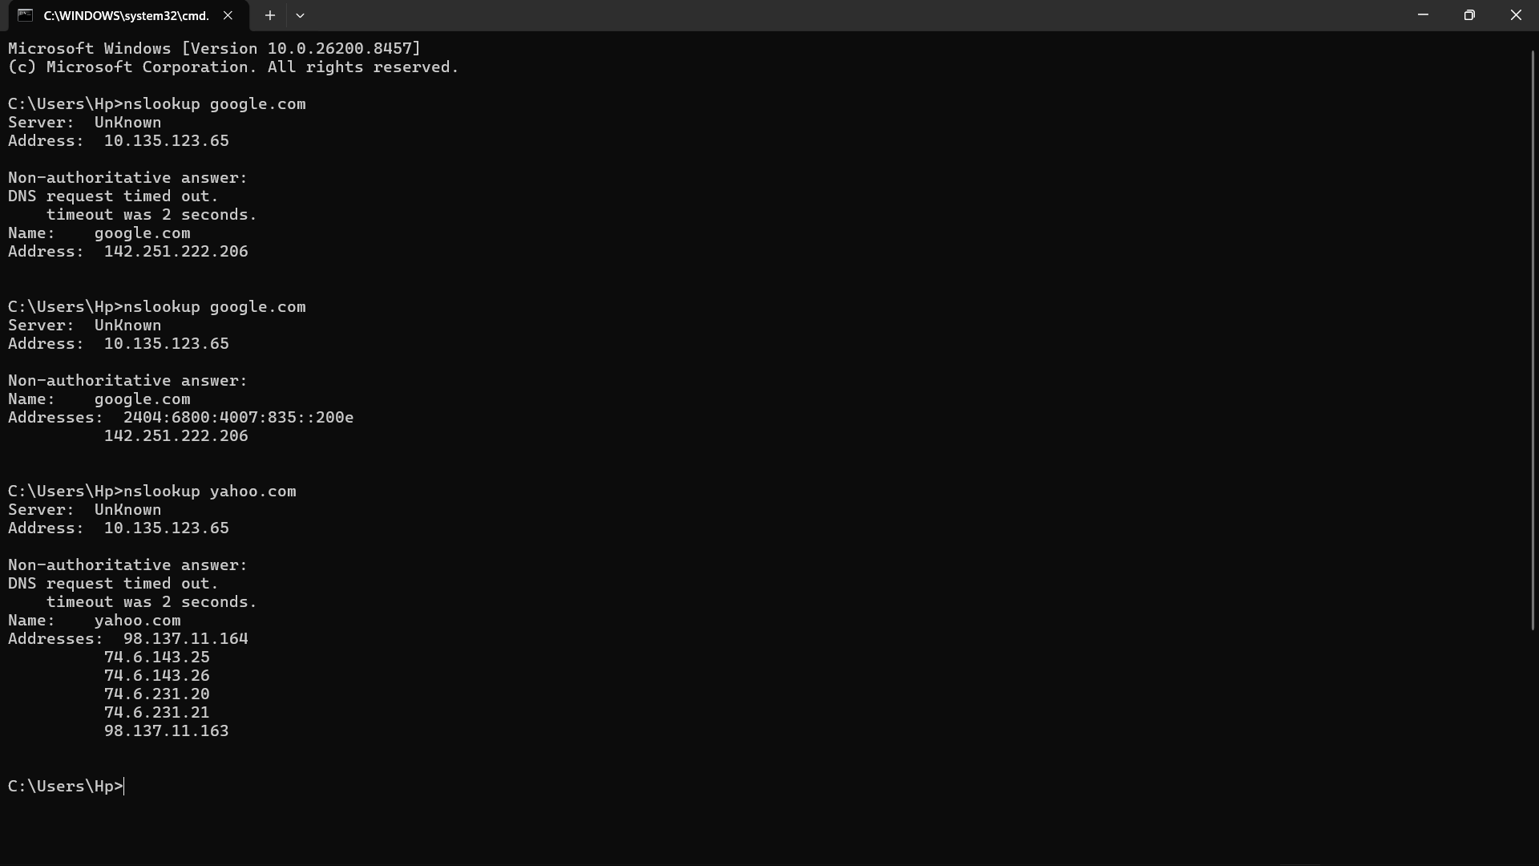
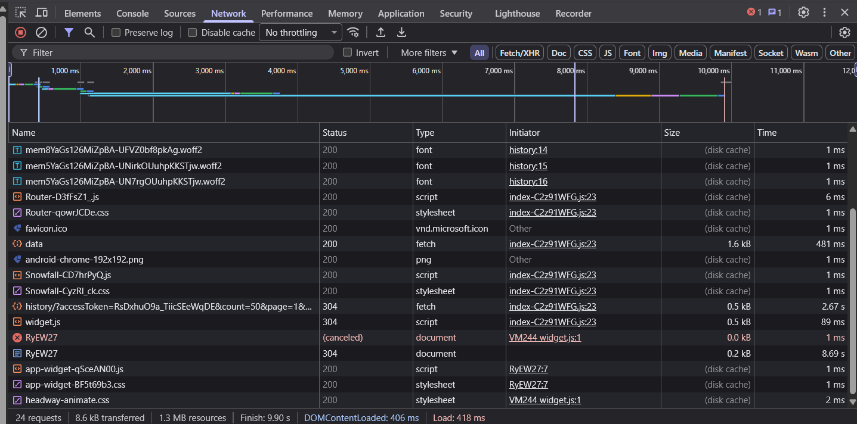
2. dev tool used in browser for monitoring the flow of requests / responses with status code (200-ok / 304-not modified)

